**DAILY ONLINE ACTIVITIES SUMMARY**

|  |  |  |  |  |  |  |  |  |
| --- | --- | --- | --- | --- | --- | --- | --- | --- |
| **Date:** | **9-6-2020** | | | | | **Name:** | **Prajna** | |
| **Sem & Sec** | **8th sem ‘B’** | | | | | **USN:** | **4AL16CS067** | |
| **Online Test Summary** | | | | | | | | |
| **Subject** | | **BDA** | | | | | | |
| **Max. Marks** | | **30** | | **Score** | | | **25** | |
| **Certification Course Summary** | | | | | | | | |
| **Course** | **Introduction to hathical hacking** | | | | | | | |
| **Certificate Provider** | | | **Great Learning** | | **Duration** | | | **50min** |
| **Coding Challenges** | | | | | | | | |
| **Problem Statement:**1**.** Write a c program to program to convert the string to uppercase. | | | | | | | | |
| **Status: Completed** | | | | | | | | |
| **Uploaded the report in GitHub**  **GitHub link:** | | | | | **Yes**  **https://github.com/alvas-education-foundation/prajna_k** | | | |
| **If yes Repository name** | | | | | **prajna_k** | | | |
| **Uploaded the report in slack** | | | | | **yes** | | | |

Online Test Details: (Attach the snapshot and briefly write the report for the same)

Certification Course Details: (Attach the snapshot and briefly write the report for the same)

Coding Challenges Details: (Attach the snapshot and briefly write the report for the same)

1)online test

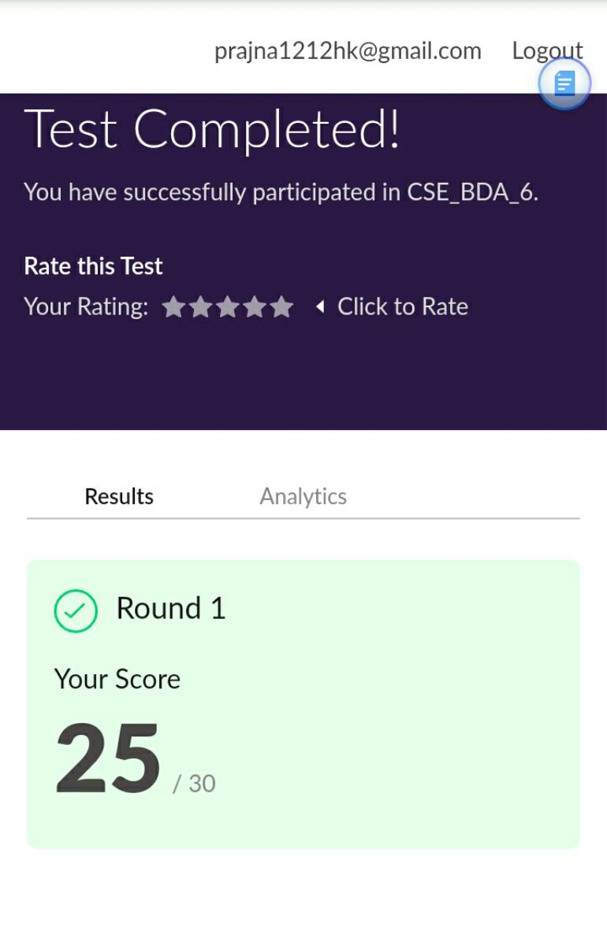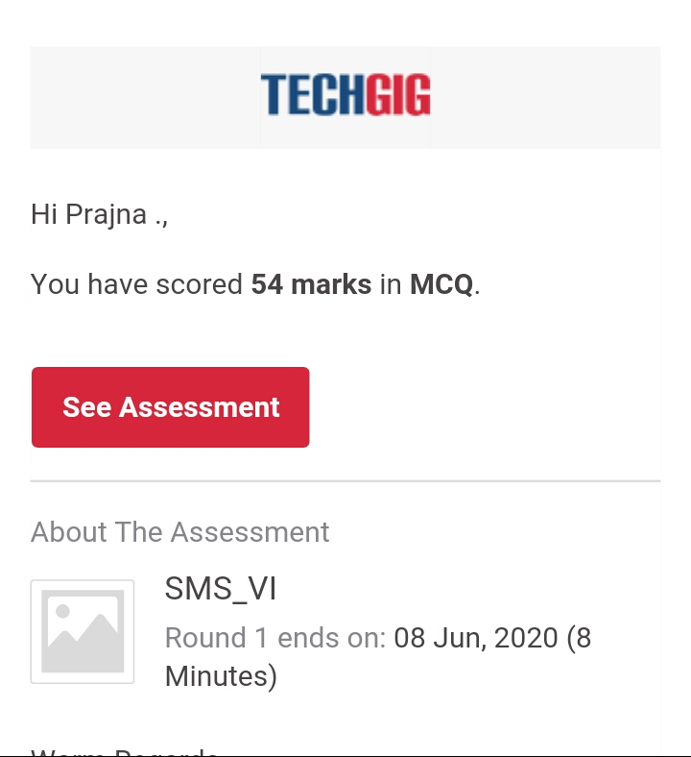

2) certification course

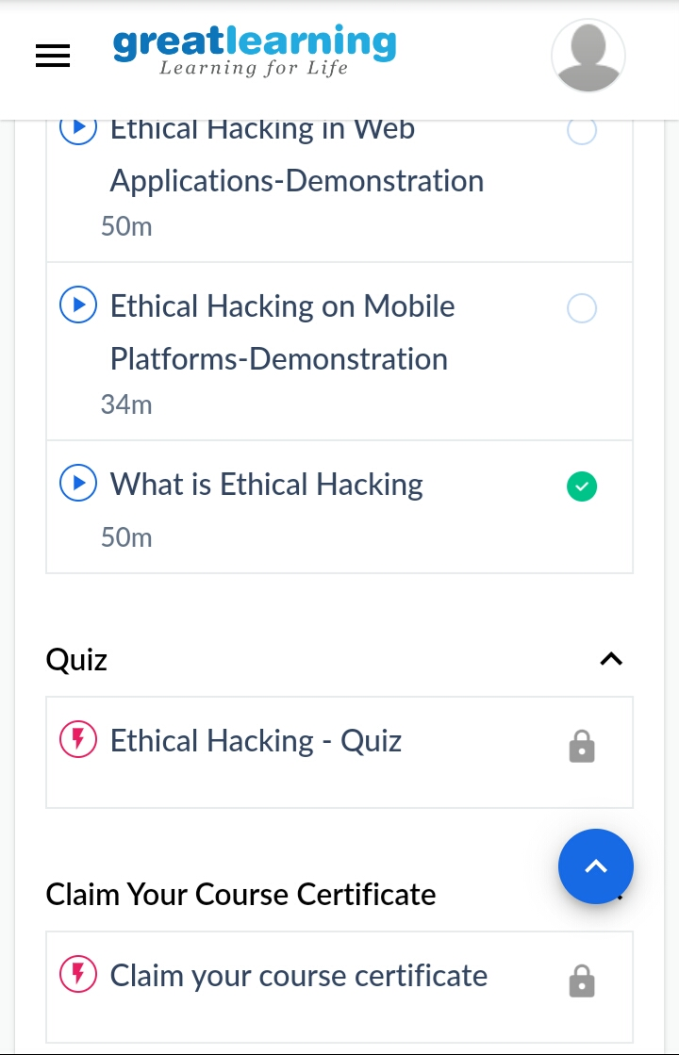

3) coding challenges

Program 1

#include<stdio.h>

#include<ctype.h>

int main()

{

int ctr=0;

char str_char;

char str[100];

printf("\n Convert a string to uppercase. :\n");

printf("-----------------------------------");

printf("\n Input a string in lowercase : ");

fgets(str, sizeof str, stdin);

printf(" Here is the above string in UPPERCASE :\n ");

while (str[ctr]) {

str_char=str[ctr];

putchar (toupper(str_char));

ctr++;

}

printf("\n\n");

return 0;

}

|  |
| --- |
|  |
|  |  |
|  |  |
|  |  |
|  |  |
|  |  |